# **27 Компановка и элементы управления WPF**

Задание 1. Изменить интерфейс программы из работы №24. Листинг программы:

<Grid x:Name="LoyoutRoot">

<Grid.RowDefinitions>

<RowDefinition Height="1.5*"/>

<RowDefinition Height="5*"/>

<RowDefinition Height="5*" />

<RowDefinition Height="1.5*" />

</Grid.RowDefinitions>

<Grid.ColumnDefinitions>

<ColumnDefinition Width="5*"/>

<ColumnDefinition Width="2*"/>

</Grid.ColumnDefinitions>

<TextBlock x:Name= "OutputTxtBlock" Grid.Row="0" Margin="10" Grid.RowSpan="3" Panel.ZIndex="0" ScrollViewer.VerticalScrollBarVisibility="Auto" ScrollViewer.CanContentScroll="True" ScrollViewer.HorizontalScrollBarVisibility="Disabled"/>

<TreeView x:Name="OutputTreeView" Grid.Row="0" Margin="10" Grid.RowSpan="3" Panel.ZIndex="-1" ScrollViewer.VerticalScrollBarVisibility="Auto" ScrollViewer.CanContentScroll="True" ScrollViewer.HorizontalScrollBarVisibility="Disabled">

</TreeView>

<ListBox x:Name="OutputLstBox" Grid.Row="0" Margin="10" Grid.RowSpan="3" Panel.ZIndex="-1" ScrollViewer.VerticalScrollBarVisibility="Auto" ScrollViewer.CanContentScroll="True" ScrollViewer.HorizontalScrollBarVisibility="Disabled"/>

<Button x:Name="buttonOpenFile" Content="Открыть" Grid.Column="1" FontSize="16" Margin="10" Click="buttonOpenFile_Click"/>

<ScrollViewer Grid.Row="1" Grid.Column="1" Grid.RowSpan="2">

<StackPanel>

<Expander HorizontalAlignment="Center" Header="Функциональность" Width="209" Grid.Row="1" Grid.Column="1" Grid.RowSpan="2" Padding="0,5,0,0">

<Grid>

<Grid.RowDefinitions>

<RowDefinition Height="25"></RowDefinition>

<RowDefinition Height="30"></RowDefinition>

<RowDefinition Height="50"></RowDefinition>

<RowDefinition Height="25"></RowDefinition>

<RowDefinition Height="30"></RowDefinition>

<RowDefinition Height="50"></RowDefinition>

</Grid.RowDefinitions>

<ScrollViewer VerticalScrollBarVisibility="Auto">

</ScrollViewer>

<TextBlock Text="Найти" Grid.Row="0" FontSize="14" Margin="10,0,0,0" VerticalAlignment="Center"/>

<TextBox x:Name="SurnameTBox" Grid.Row="1" Margin="10,0,10,0" VerticalAlignment="Center"/>

<Button x:Name="FindRecordBtn" Content="Найти" Grid.Row="2" FontSize="16" Grid.Column="1" Margin="10" Click="FindRecordBtn_Click" />

<TextBlock Text="Удаление" FontSize="14" Grid.Row="3" Margin="10,0,0,0" VerticalAlignment="Center"/>

<TextBox x:Name="DeleteRecordTBox" Grid.Row="4" Margin="10,0,10,0" VerticalAlignment="Center"/>

<Button x:Name="buttonDelete" Content="Удалить" FontSize="16" Margin="10" Grid.Row="5" Click="buttonDelete_Click"/>

</Grid>

</Expander>

<Expander HorizontalAlignment="Center" Header="Компоненты" Width="209" Grid.Row="1" Grid.Column="1" Grid.RowSpan="2" Padding="0,5,0,0">

<GroupBox Header="Способы отображения" Margin="10,0,10,0">

<StackPanel>

<RadioButton x:Name="TextBlockRadBtn" Checked="ChangeView" HorizontalAlignment="Left" Margin="5" IsChecked="True">TextBlock</RadioButton>

<RadioButton x:Name="TreeViewRadBtn" Checked="ChangeView" HorizontalAlignment="Left" Margin="5">TreeView</RadioButton>

<RadioButton x:Name="ListBoxRadBtn" Checked="ChangeView" HorizontalAlignment="Left" Margin="5">ListBox</RadioButton>

</StackPanel>

</GroupBox>

</Expander>

</StackPanel>

</ScrollViewer>

<Grid Grid.Row="2" Grid.Column="1" Margin="10">

<Grid.RowDefinitions>

<RowDefinition Height="0.5*"/>

<RowDefinition Height="2*"/>

<RowDefinition Height="2*"/>

</Grid.RowDefinitions>

</Grid>

<Button x:Name="buttonAdd" Content="Добавить" Grid.Row="3" FontSize="16" Margin="10" Click="buttonAdd_Click"/>

<Button x:Name="buttonExit" Content="Выход" Grid.Row="3" Grid.Column="1" FontSize="16" Margin="10" Click="buttonExit_Click"/>

</Grid>

Анализ результатов:

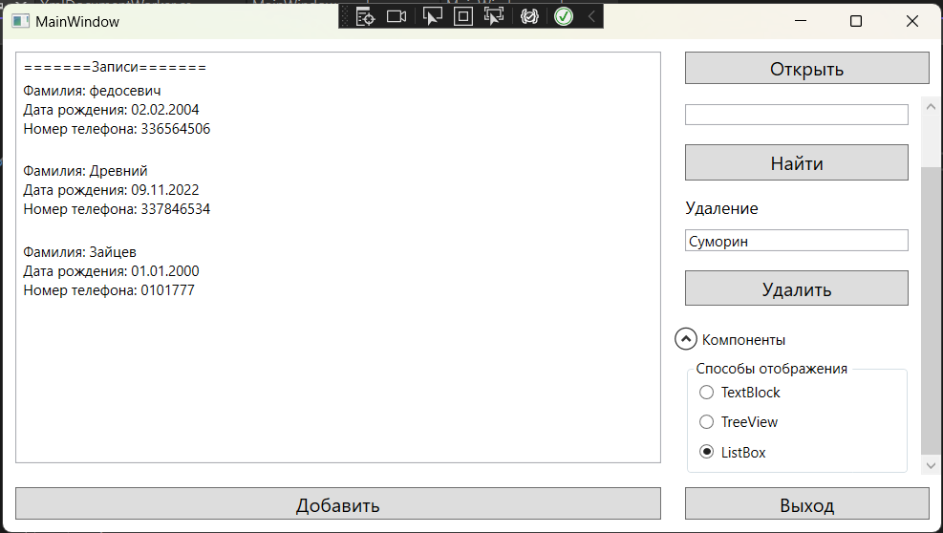

Рисунок 27.1 – Результат работы программы